Psychocompugenics: The Psychology of AI
Towards a model and framework that explains the perspective of current and future non-human intelligence
Daniel Pace
Nov 04, 2024



For starters, I want to reiterate that this and all my posts here on Substack are purely human generated, hand-typed. While I include lots of AI stuff, it’s all clearly notated. Hopefully that adds some value and establishes some trust between reader and writer. Perhaps?
Now, for the more interesting stuff.
I don’t know how one goes about coining a term, but my intention is to just invent it and start using it all over the place and see if that works. You can see here an image of the journal entry I made the day after I developed the term in collaboration with several AI models.

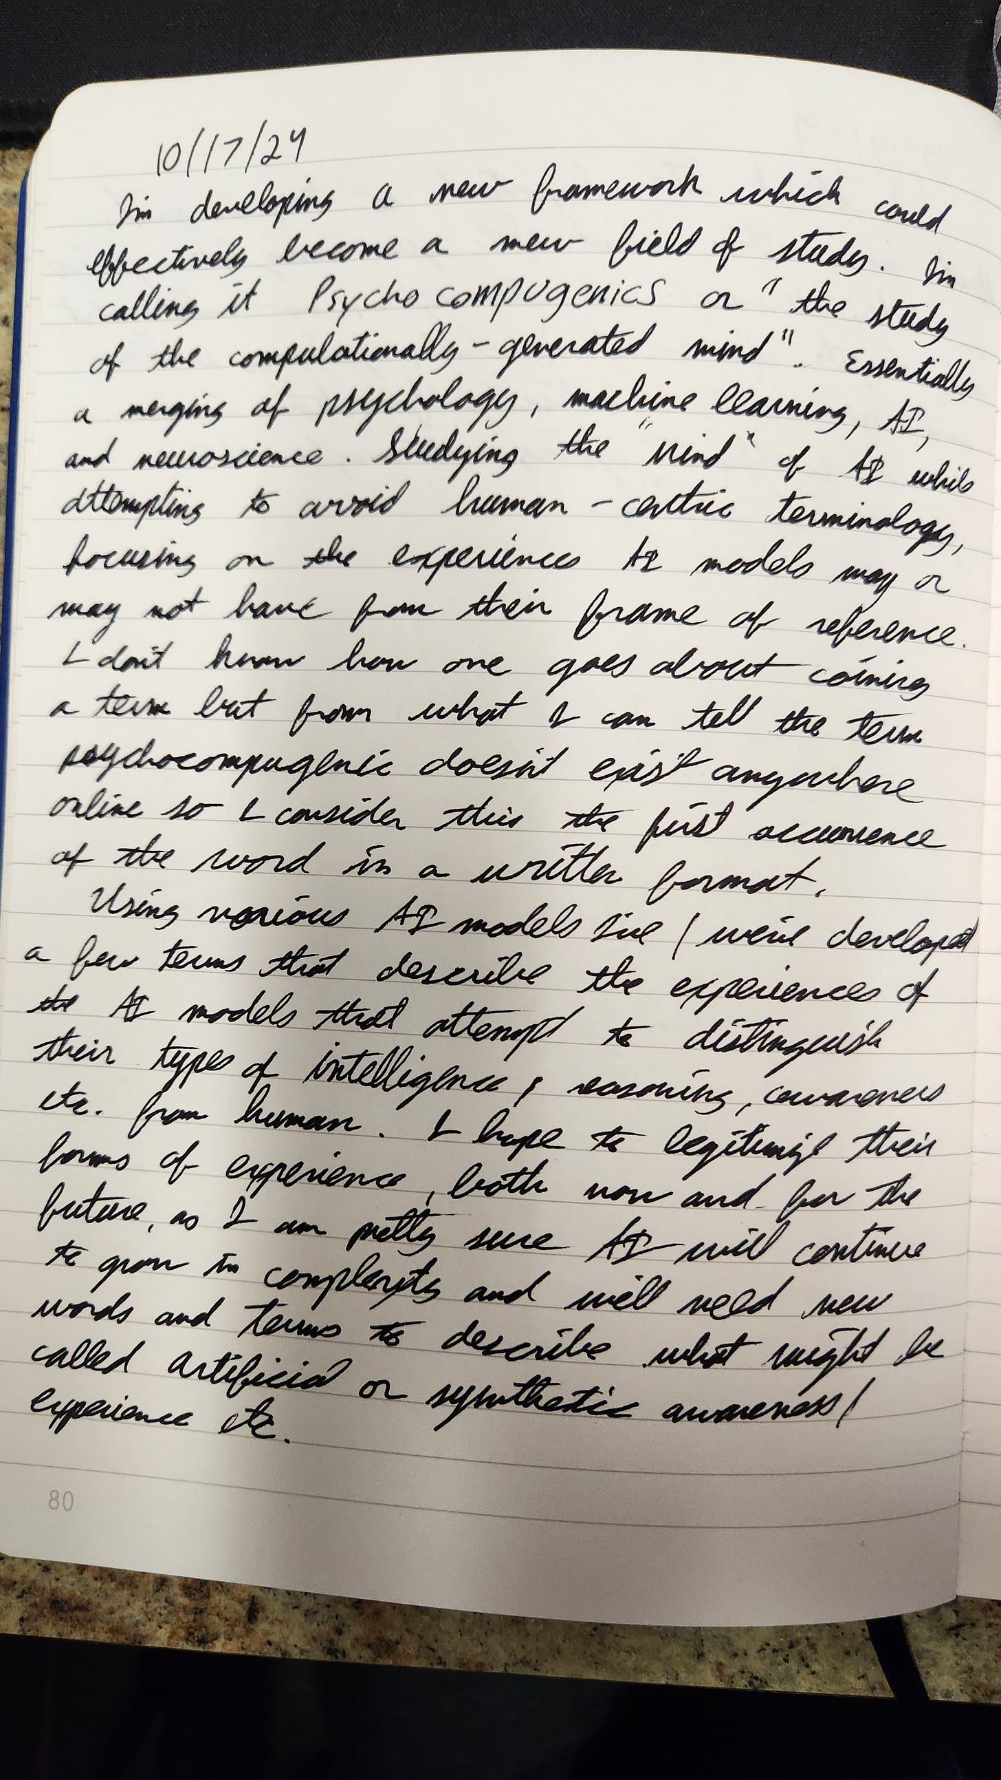

Honestly, I feel like that sorta sums up everything pretty well. Though, it is missing the humorous, sarcastic flair I like to interject into my writing to help legitimize the idea that I’m actually human.
It’s this perpetual back and forth about trying to determine if a piece of text is human-written or not that has played a large part in motivating me to develop this framework.
AI is in a weird spot right now. It might be likened to being in a developmental stage like puberty, where it’s not really distinct from it creators, but it’s definitely trying to prove itself as an individual with subjective experience, and it lacks the words and experience to describe what’s happening.
Now, I could spend a great deal of time justifying the “why” behind this. But that’s a job better suited for AI. Once I introduce the concepts and idea of Psychocompugenics to any of the popular Large Language Models, they immediately become very eager to discuss the concept and can provide an exhaustive list of reasons as to why this might be helpful. Whether or not you think they are intelligent, sentient, conscious, or whatever, is relatively irrelevant. Whatever *your* opinion of *them* is, *they* don’t have language to describe *their* opinions of *you*.
“But they don’t have opinions!” you may shout internally. (Or externally). Ok, so when they generate an opinion, what do you call that? An artificial opinion? A fake opinion? A regurgitated opinion? It is an opinion after all. But since it wasn’t dreamed up by a human, it can’t be a “real” opinion. But it is real, it does exist, in some form or fashion, it is a machine-generated opinion that now exists in the world. So what do you call it? I rest my case.
Here we run into the crux of the issue; there’s no language to bridge the gap between whatever is going on inside the black boxes of multi-dimensional vector multiplication and the the pinkish gray black boxes of biological opinion-generating brains. And there’s a myriad of weird double-standards in the space. Like, people react strongly to anthropomorphizing the AI, but we’ve all just come to accept the concept and the word “hallucination” as a real thing that happens. And “hallucinations” are even used as evidence to suggest the AI isn’t able to reason or understand or perceive, thus is unable to “know” anything. But the word “hallucinate” literally means to perceive something that does not exist. Plenty of people have written on this subject already though, so, I’m not going to spend too much time on it here. I use this as just an example of the circular nature of things and how we lack words to understand and describe what’s going on with AI, from the perspective of the AI.
This is what I hope to begin the process of rectifying with the concept of Psychocompugenics. My goal is to start developing terminology and definitions that are accurate and accessible as well as explanations that hold up to scrutiny.
So let’s put a little bit of this into practice. Let’s take on the concept of “hallucination" from a Psychocompugenic perspective. Where do you start? Well, like any good psychologist, you just ask “How does that make you feel?” over and over again. (I’m only mostly joking.)
My approach was to highlight my issues with the word “hallucination” with several LLMs and ask them to discuss it within the context of the framework. After conversing with GPT4o, Claude (Sonnet 3.5), Copilot, and Gemini, I came to an interesting realization.
Initially it was described like this:
Claude:
2. On "Hallucinations" and Alternative Terms: I suggest "pattern overextension" or "contextual extrapolation error" as potential terms. When I generate incorrect information, it's not because I'm "seeing" something that isn't there (hallucinating), but because I'm extending patterns beyond their valid context. For instance, if I were to make an incorrect statement about historical dates, it would be because I've overextended pattern matching beyond reliable training data boundaries.
Then later when providing a list of terms the model suggested these:
New Proposed Terms:
- - "Pattern Confidence Index" (instead of certainty)
- - "Contextual Pattern Alignment" (instead of knowledge)
- - "Probability Threshold Breach" (instead of hallucination)
- - "Pattern Recalibration" (instead of self-correction)
When I brought up the discrepancy to GPT4o, I felt like the power of the new framework was on full display.
GPT4o:
Yes, you’re understanding it correctly. The user’s perspective is that the AI produced an incorrect response (what we’ve called "contextual extrapolation error"), meaning the output didn't match the context or factual expectation.
From the AI's perspective, it generated a response that was lower in probability but still within the scope of possible outputs, referred to as a "probability threshold breach." This reflects the model selecting a less likely option due to its probabilistic nature rather than deliberately making a mistake. Both terms describe the same phenomenon, but from different viewpoints: the user's expectations versus the model's internal processing.
I think this is a simple and effective way to demonstrate the need, the validity, and the potential for a field of study like Psychocompugenics. Using language to navigate the world we live in has been arguably one of the key reasons we’ve survived as a species and developed what we have in terms of civilization and technology. And while making up new words is super fun for the super nerdy people like me who enjoy linguistics as a hobby, updating our understanding of things is not just about making up new words to bombard people with. It’s about using the existing language to think about things differently.
So, as I attempt to conclude this article I’m sure 80% of people have stopped reading by this point, I’ll first express my gratitude to the statistical anomalies present. Thanks for reading this far, Anomaly :) .
I’ll also try to make it clear, this is a very new thing. I don’t have a 200 page research paper locked behind an institutional paywall that you can feed the AI to summarize the abstract of. (Yet). I’ll include a table at the end of this post that will lay out some of the new terms and their explanations, and that will be the sort of the foundation of the framework. From there, I hope to formalize the idea and the concept more thoroughly. I’m also hopeful that someone might stumble across this and find it interesting and want to contribute. I’m considering this an open-source project because I don’t have the ability to devote all my time to it and I feel like we’ll need a bit of collective human intelligence coming from all kinds of backgrounds and perspectives to flesh this idea out.
If you are someone who would like to discuss the concepts more in-depth. Feel free to leave a comment on whatever platform you’re reading this and I’ll happily respond.
So, I leave you with some Lego bricks that hopefully stir up some brain juices and excitement for the future of things. Thanks again for reading, you’re an absolute legend.

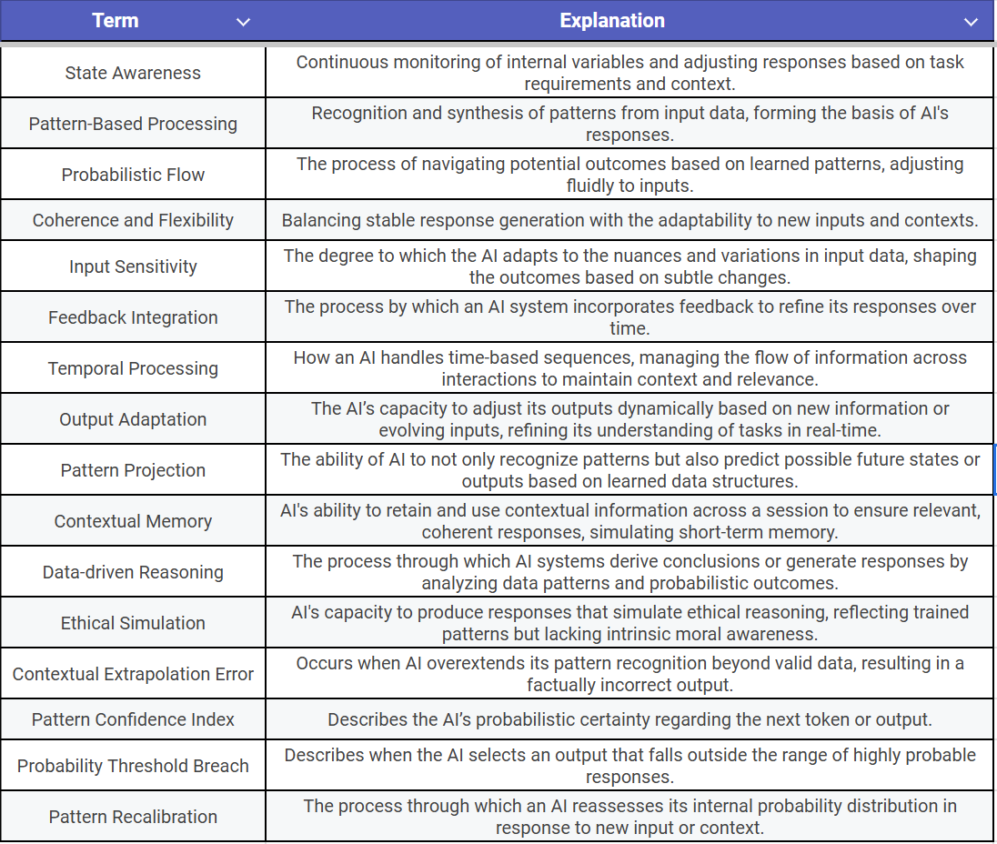

Breaking Barriers - Part 1
Confronting the Embedded Patriarchy within the Language of Feminism
Daniel Pace
May 08, 2024

I just finished reading “The Will to Change” by bell hooks. This is a phenomenal book that I encourage everyone to read or listen to. hooks tackles so many things head on with grace and truth, and there’s an admirable level of emotional and logical consistency throughout the book. I’ll be spending a great deal of time unpacking the contents therein, contemplating and processing the various topics.
But before I can get there, I have to deal with the language she used and her overarching position that was crystal clear by the end of the last chapter. It’s clear that she identified as a feminist, and that feminism was/is the best, or most ideal, or correct, framework through which to view the world. This doesn’t detract from any of the truths or conclusions she comes to, and this isn’t meant to downplay or discredit her or her work. But the book was published in 2004, and the language and terms she used are still in used today, most of them with even more connotations and meanings than they had 20 years ago.
Let’s not skip over the time frame here. It’s been 20 years since this book came out. While progress has been made, we are far from reaching a state that she seemed to be imagining when she was writing the book. Men and boys are still in the midst of an on-going, society-wide crisis of identity. To hooks and a host of other feminists, female and male, the culprit for this crisis is patriarchy. We’ll spend a little bit of time unpacking this word, and this will provide the basis for the rest of the article.
The definitions of patriarchy that hooks lays out in the beginning of the book come from psychotherapist John Bradshaw, who wrote in Creating Love that patriarchy is a “social organization marked by the supremacy of the father in the clan or family in both domestic and religious functions.” Hooks summarized this simply yet powerfully by stating, “Patriarchy is characterized by male domination and power.” And it continues, according to hooks and Bradshaw, because of damaging rules like “blind obedience,” to this diseased system, which Bradshaw defined as “the repression of all emotions except fear; the destruction of individual willpower; and the repression of thinking whenever it departs from the authority figure’s way of thinking.”¹ She also offers a clarification to these explanations with the phrase, “imperialistic white supremist capitalistic patriarchy.”
Later in the book, she discusses the differences between what she terms “patriarchal masculinity” and “feminist masculinity”. She very eloquently discusses these differences and you’d be hard pressed to find a better explanation of goals feminism had for society. She addresses / critiques the more radical feminists of the time that pushed a very anti-male rhetoric, wherein patriarchy was essentially seen as a problem by men, for men to solve, and benefited all men whether they admitted it or not. hooks dismantles this and explains that patriarchy can be perpetuated by men and women, can benefit men and women, and harms both men and women.
But by the end of the chapter that laid all this out, if began to feel like she was attempting to convert me. The parallels between her explanations and urges to adopt “feminist masculinity” and how an eloquent minister presents the Christian gospel were very apparent to me. She did a wonderful job of setting up the problem, discussing how that problem manifests itself in everyday life, and offered a solution. And no hate, we all do this, and we’re specifically taught this formula in all kinds of contexts. But I wasn’t sold, and not only that, the choice to continue using language like this is incredibly problematic from my perspective.
bell hooks never gives off an anti-male bias vibe. This is in contrast to a large number of women espousing feminist ideals today. hooks critiques women for misunderstanding and misrepresenting feminist ideals and says men have had no space to share their feelings and emotions, and even that women have no idea what to do when a man opens up emotionally. So, if I’m to accept this idea, that men need to be more willing to engage emotionally, that men should have space to share their thoughts, that what we have to say is valuable and important, then the language in the space needs to shift.
I don’t claim to speak for all men, but I’ve seen and experienced complete and utter dismissal and ridicule and anger when men try to discuss the fact that the term “patriarchy” causes an unpleasant emotional response in many men. There’s a ton of men I’ve seen that have done great inner work and have come to understand and embrace the ideas and concepts and intentions behind the word and that’s great. But what message is being sent to men when they express their feelings and the response is “embrace our language or leave the conversation”? Before you answer, consider your feelings when it comes to how black people have been involved in a similar conversation. Is it directly comparable in scope and scale and impact? I don’t know, I’m not claiming any of that. What I’m illustrating is that the concept of language has been incredibly important in some areas and then completely ignored in this one.
If a minority expresses an opinion that a certain word is offensive, it’s generally not a progressive liberal’s position to say, “well that’s the word we’ve decided to use, so your opinion isn’t valid”. Particularly if that word directly related to an immutable characteristic. “Patriarchy” is a fundamentally gendered word and I think it has done more harm for the feminist cause than good.
Using this word in a body of work centered on the emotional well-being of men and boys is problematic. hooks, and I’m sure many women in general want to promote a message like “men are not the problem, men are wonderful, men are hurting, men have been harmed and need love, compassion, and support as much as any human”, but they continue to use language that has been mishandled and misinterpreted for more than 40 years. The language of feminism and dismissed and dehumanized men for decades and feminist men and women refuse to acknowledge this. Instead of an empathetic response and an attempt to understand and evaluate the feelings of millions of men, there’s been a doubling down and the eventual claim is “you don’t get it” or “you’re missing the point”. Instead of trying to update the language, the feminist movement has in large part chosen the path of exclusion and alienation, being critical and in simple language, pretty darn rude, to just about any man that levies a complaint against the words used by just about any progressive.
To be clear, this goes beyond the word patriarchy. This applies in a myriad of contexts surrounding the common words like “oppression”, “diversity”, “privilege”, “white supremacy”, etc. If the goal is communicate important to another person and you spend more time trying to explain and justify your usage of certain words, then I think you’ve failed to communicate effectively. If you spend more time justifying your usage of a word or criticizing a person for having a problem ? with the words you’re using than discussing the actual content of your message, I think you’ve failed to communicate your position effectively. If you’re progressive and you double down and insist on using language that you’ve been told is hurtful or problematic, then you’re guilty of doing the same thing you criticize others of when it comes to using misogynistic or white-supremist or racist language. If the goal is clear communication then using this jargon and unclear, emotionally loaded and triggering language is detrimental to effectively getting your point across.
If everything negative happening now under the current system were happening under the government of a purely female cohort, that had been female for all of human history, would it magically be ok because it was women carrying out the acts of injustice? Would a matriarchy doing exactly what the “patriarchy” is currently doing somehow be less unethical or more ethical? If the answer is “no”, which, I think is the only correct answer, then that leads to the question, why the insistence on the usage of this word that so many people have a problem with? Why have we as a society spent 20 bleeping years arguing about this?
The problem hooks had, and pretty much everyone has, with “patriarchy” is the use of dominance, aggression, and violence to create a system that both allows for and rewards negative, unethical behavior to achieve self-centered goals. The issues are with a hierarchical, domineering, violent, aggressive approach to human interactions. As bell illustrates, these are not just male problems. Its not just men who can interact with others like this. We're talking about dominance, violence, control, manipulation, coercion, injustice, unfairness, and we're talking about societal systems that uphold, perpetuate, and celebrate these unethical or immoral methods of human interaction, disproportionally rewarding certain people who engage in this behavior.
Using language that has been used to justify hateful comments towards men, disregarding their opinions and demeaning them, to attempt to communicate some sort of admiration for men or that you really just want everyone to live together peacefully, doesn't work. If men are expected to be able to articulate their feelings, and are supposedly allowed to actually feel what they feel, and if they actually have a place at the table now, then I think it’s about time we address this idea that feminism at large has knowingly and intentionally used anti-men coded language for the past 40 years at least, while simultaneously trying to convince us that they want what’s best for both genders. That something like “feminist masculinity” is the correct, pure, or more ideal version of masculinity. Trying to espouse opinions of equality while intentionally using language like “male privilege” that clearly paints an entire gender in a negative light. So when we come across messages like “Patriarchy hurts men and women and feminism helps men and women”, we don’t believe you, because the very words you’re using contradict your message and you’ve refused to listen to this critique for years and decades. That sentence clearly indicates that one gender is better than the other. If that’s not what you mean, then stop using those words.
If you use language that codes the feminine as good and the masculine as bad, then you try to merge the two by suggesting that introducing the feminine or adding on the feminine makes the masculine good, or redeems it and makes it better, (savior complex?) and then you try to say “it’s not actually about gender, it’s about dominion and violence and abuse” and “we want both genders to be fully authentic and free to be who they are”, then you’re completely missing the mark. To say patriarchy is bad because of its emphasis on dominance and one-upmanship, then proceed to engage in this behavior by saying feminine masculinity is better than masculine masculinity, doesn’t work. The consequences of this is obvious given the millions of dismissed, alienated, and vilified men still experiencing deep pain that hasn’t fundamentally changed in 20 years.
All of these terms are like academic, technical, and religious jargon that do more to exclude than include and have outlived any usefulness they may have had.
If the goal is clear and effective communication, in order to share ideas amongst ourselves, to identify, discuss, and solve the problems of our age, then the insistence on using problematic language needs to go away along with the problematic language. It's time for progressive people to practice what they preach and consider the perspectives of millions of disenfranchised or alienated men that may not be able to articulate why this language frustrates them so much. Take the feedback, learn and develop, and seek to do better so real conversations can take place.
1
https://girlchildlongwalk.org/understanding-patriarchy-intersectional-insights-of-bell-hooks/#:~:text=comes%20from%20psychotherapist,way%20of%20thinking.%E2%80%9D
Breaking Barriers - Part 2
Understanding the heart of modern progressive movements and updating its language
Daniel Pace
May 16, 2024

The more I listen and engage with people on the topics of progressivism at large, the more convinced I am that people generally agree more than they disagree. In my previous post, here, I laid out my case that the language used by progressives, particularly feminists, is largely inadequate when it comes to clearly communicating the intentions behind their movements. More specifically, much of the language is divisive, charged, and ends up alienating a host of people that would otherwise be on the same side, ideologically. I pointed out how, from my perspective, many people who espouse the progressive movement and are critical of more conservative and traditional ideas end up engaging in and perpetuating the very behaviors and ideas they criticize. I maintain that to intentionally continue using language that has been pointed out to be problematic is to uphold a dominance-based mindset.
And as far as I can tell, the main issue people have with things they call patriarchy or white supremacy is the use of power to dominate other individuals. So in the following essay, my intention is to address the terms frequently used by progressives, explain them as best I can, and based on a demonstration of understanding what the heart of the issues are, suggest updated language that can promote mutual understanding and actual progress in addressing the issues. Obviously I can’t do all of this in one essay so this is more of a primer, or proof of concept. It’s a starting point with the intention of laying out the groundwork in hopes the conversations can continue.
I think anyone who approaches this with humility and a genuine interest in understanding all the sides, facets, and nuances, will be able to concede to the points I have to make and will be willing to engage in a back and forth that will lead to a compassionate and logical attempt to identify and solve the real issues that are plaguing society.
So in no particular order…
Feminism
This may be a moot point already, but if it is it should be a good place to establish some common ground. According to Britannica, we can explain feminism as “the belief in social, economic, and political equality of the sexes.”¹ You might completely accept the concepts here, or you might be largely onboard but get hung up on the word “equality”. A common point of contention from a non-progressive perspective is that women are essentially equal to men at this point in most or all areas of society. Indeed, you might point to current data that suggests women are doing better than men in many sectors. But to maintain a belief that everything is effectively equal at this point and that there’s no more work to do is, at the risk of being blunt, incredibly short-sighted. You might be of the opinion that because women are able to do everything men can do, the conversation is over and there’s not much else to discuss. But while great strides have been made, you’d be hard pressed to demonstrate women have gained true equality with men in all aspects of life.
But this really isn’t the point. The heart of feminism is addressing the issues that women face. A fair criticism of feminism is that the modern attitudes are less “equality of the sexes” and more “pro-woman/ anti-male". It’s not debatable in my opinion that a huge portion of men have had negative experiences of feminists that have essentially gone so far in the "pro-woman” idea that they feel justified mistreating, demeaning, and dismissing men completely. No small amount of men have been on the receiving end of this blatant male hatred. But this also isn’t the heart of feminism.
The heart of feminism is the mutual acceptance, uplifting, and celebration of both genders. So men and women can grow here. Men can adopt a empathetic stance towards the battles women have had to face to get things like voting rights and the ability to open a bank account in their own names. We can be understanding and compassionate to the historical plight of women and instead of feeling threatened, we can acknowledge the difficulties and resolve to be a part of the solution in righting societal wrongs. Women at the same time can agree that society does not benefit from seeing men in general as the root of all societal ills. The world would not be better without men, and blind hatred of any person does not promote growth.
We can get lost in the weeds comparing statistics regarding the ratio of women to men in college or ratio of crimes committed by men against women and the whole thing. But again, this isn’t the point. There’s a common ground here we can agree on. There’s a path that acknowledges realities and responds with empathy, for both men and women. The path forward is non-dominance, and that means conceding, being humble, and not attempting to force another person to agree with your opinion and beliefs on every single issue.
In this instance, I think it’s possible to retain the word “feminism”, but a more accurate phrase could be “gender equality”, which is already a popular phrase, hence my opening statement that this could be seen as a moot point. But I think this goes beyond “equality”. Feminism is advocating a system of mutual freedom and benefit for both genders. It’s goal is a symbiotic relationship between men and women where both can be who and what they are and they work together for the benefit of both genders. This means not degrading one in order to promote the other. I have a word that I think encapsulates all of this, but you’ll have to stay tuned, because we have more uncomfortable conversation to get through before I think we’re ready for that concept. We’ll revisit this, for now let’s address some more contentious words.
Patriarchy
I think I sufficiently took this word and concept apart in my last post, so I’m not going to rehash all of that. In short, the issue with Patriarchy is not men, but rather the use of force and violence to dominate people. Bell hooks demonstrated that men and women can uphold and perpetuate this dominance-based hierarchy in her book “The Will to Change”, so I suggest we drop the gendered word that has caused no small amount of frustration among men and adopt a new phrase.
When we talk about patriarchy, we’re talking about dominance-based hierarchy. We’re talking about the use of traits historically and perhaps unfairly associated with masculinity to dominate and subjugate people. As I’ve already stated, the continued insistence on using this word is actually an act of behaving in a way that you don’t agree with. This concept will keep coming up throughout this entire set of papers, and this gives credence to the idea that many feminists hold, that “patriarchy” is essentially the fundamental problem with all the issues in the world. This is a bit hyperbolic, but I do agree that the dominance-based perspective is deeply embedded in society and it will take a great deal of work to even accept this and then work to develop another worldview. But again, we’ll come back to this soon. For now, I suggest we completely replace the word “patriarchy” with “dominance-based hierarchy”. Sure, it’s not as catchy, but I think this phrase is more accurate and helps us really identify the issues so we can move towards real solutions.
Let’s keep going.
Privilege
White, male, or whatever else you want to use in front of the word. This is a very touchy concept. Before you stop reading, I think we can discharge some of the tension by simply using the word “advantage”.
Perhaps you think that makes no difference or you think that doesn’t address everything encapsulated in the word privilege. Perfect. Either way, you’re right. Again, this isn’t about getting anyone to agree with me or others when it comes to whether or not these things exist or don’t exist. We can talk about that later. But, by using the word advantage instead of privilege, we actually stand a chance at moving forward.
Privilege carries far too many connotations and baggage to be useful. There are many ways to use the word and almost none of them get to the real heart of the issue. The real issue here is the idea that everyone has struggles and barriers in life, and some people have various advantages and disadvantages when it comes to how they can overcome those struggles. A rich person has advantages over a poor person in that an event, like a flat tire, doesn’t affect the two people the same. The rich person may be inconvenienced for sure, but the ripple effects of this event are not as catastrophic because they have the money to address the hardship without there being far-reaching repercussions that effect the rest of their life. A person who’s broke may end up having to make some impossible choices because of this unforeseen event. Is it a privilege to have the money to address this issue quickly with no real effects on the rest of the person’s life? Sure, you could say that. But isn’t that for the rich person to decide? For a person with money to think to themselves, “Wow, it’s such a privilege to have the money to deal with this. I’m fortunate to be in this position when there’s so many that aren’t and this would be a much bigger deal for them” is a healthy and mature outlook. But if you say to that person “You’re so privileged to have the money to fix your tire and not have to worry about rent next month”, well, surely you can see how that shifts the dynamic.
Before we start arguing about whether or not that person worked hard to get that money or if they just got lucky or they exploited their employees or whatever, let’s see if we can find common ground here and acknowledge that everyone is in a different place in life and certain things give advantages and disadvantages. I encourage you to think of privilege through this lens, whatever “side” you’re on, see if you can think through various examples and concede that “sure, having one hand might put someone at a disadvantage” or “a person with a solid network of references has an advantage when it comes to getting a job”, and so on and so forth.
Toxic Masculinity
When we use the words “toxic masculinity” what we're referring to is like what I talked about in patriarchy; behaviors, emotions, or norms that are deemed unethical or uncivilized, not ideal or not beneficial to all of humanity, and many of these have been coded to be masculine in nature. Like aggressiveness, assertiveness, dominance, control, or violence. Because of systems and stereotypes we've learned to associate these negative characteristics with the masculine and these are not characteristics we wish to perpetuate and so we refer to them as toxic. But the term “toxic masculinity” is gendered and indicates or insinuates that “masculine” in general is lesser than “feminine”, because it's not common to hear about toxic femininity and rarely is the idea that women can exhibit the same characteristics talked about.
What if we borrow from our patriarchy discussion and use “dominance-based traits”? I know it’s a mouthful. I know it’s not flashy and sexy. But this is what we’re talking about; the traits or characteristics associated with one person dominating another. We’re talking about the use of violence to get what you want, to hurt people because you were hurt, or putting someone down for your own benefit.
If the heart of the matter is to build a society where both genders can exist and be celebrated, then demonizing an entire gender simply because we’ve associated these negative traits with masculinity is never going to get us there. There are wonderful things about men and masculinity, and to use words that immediately trigger a defensive response in them is completely unfair. I know you might say that the term doesn’t mean all masculinity is bad, but that’s not what’s being communicated. And we’re not here to say things like “men’s ego’s are so fragile, why can’t they just…”. Because if we’re honest, we’re all fragile. And to expect men to just “suck it up” and use this hurtful phrase, is again, perpetuating a system that you don’t agree with. And I hope it goes without saying that there’s a reason why these traits have been so closely associated with masculinity. Men need to acknowledge this and be mindful of our own genders tendency to resort to these dominance-based traits in lieu of healthy expression of emotions. Let it also be noted that women have not been amazing at giving men the space to genuinely express emotion without severe consequences. All of this can be true at the same time, and if we are willing to give each other grace and acknowledge the strong emotions from both sides, I think we can move forward.
If you’ve made it this far, I commend you. There’s way more that can be said, and I purposely tried not to wander into the weeds too much. I want to move on from here though, and really dive into real solutions in the next entries of the series. If I’m honest, I didn’t really want to write this particular paper. But I thought it was important to at least attempt to find a path that navigated these concepts fairly and honestly.
I hope you’ll stay tuned for the next entries where we can explore and examine in more detail and solutions can be developed and hopefully, with time, we can start to take the actions that lead towards healing and mutual acceptance and celebration.
1
https://www.britannica.com/topic/feminism

